Directions: Cut out the pictures and glue them under the correct community.

_____________________________________________________________________________________________________________________
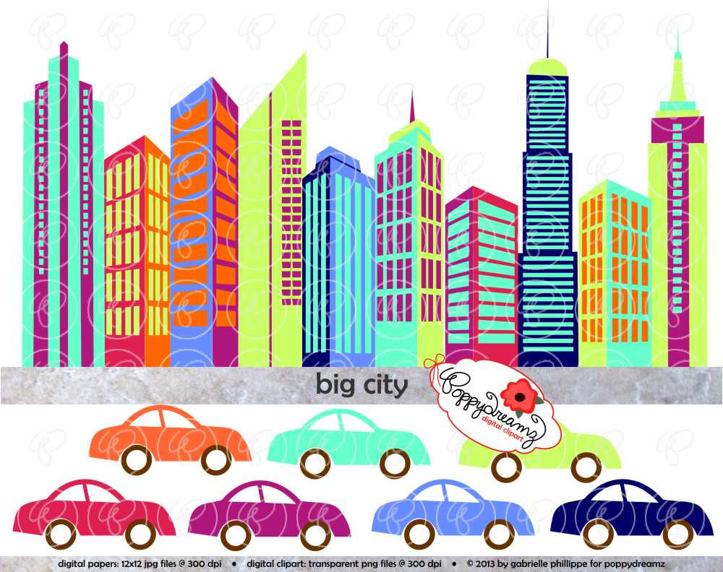
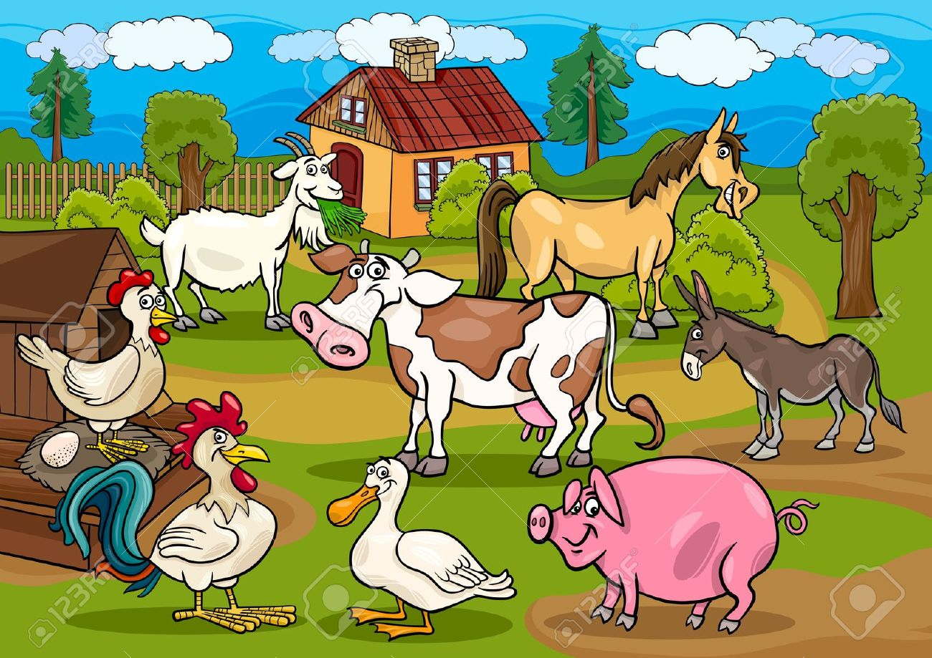
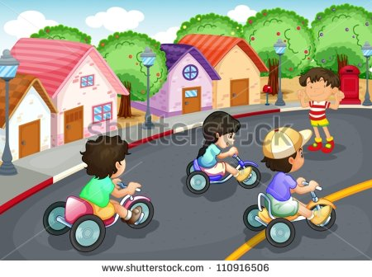

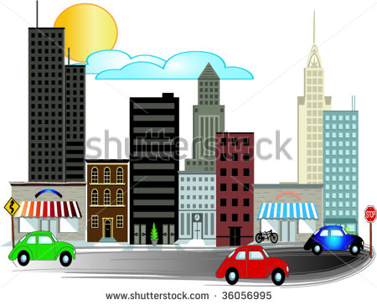

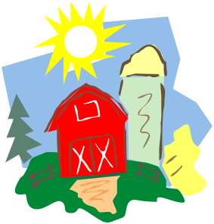
____________________________________________________________________________________________________________________
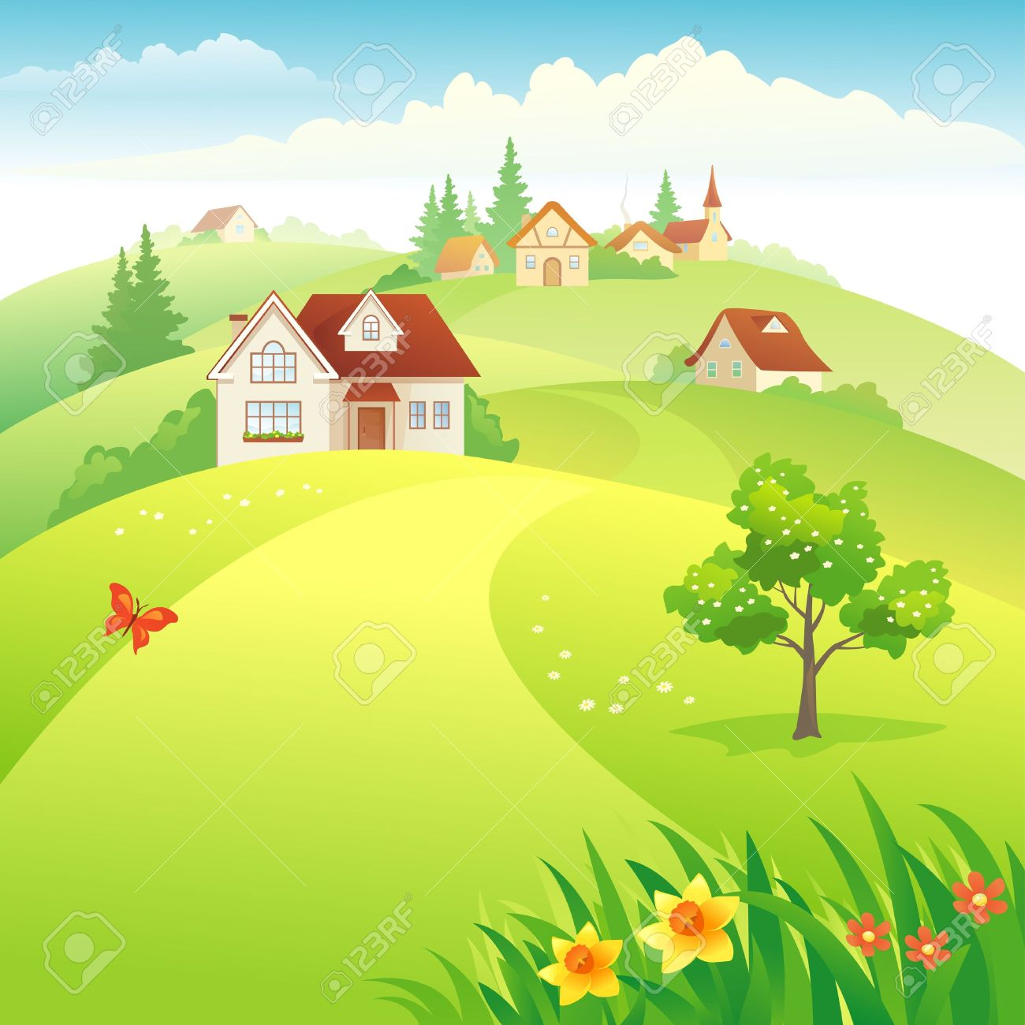
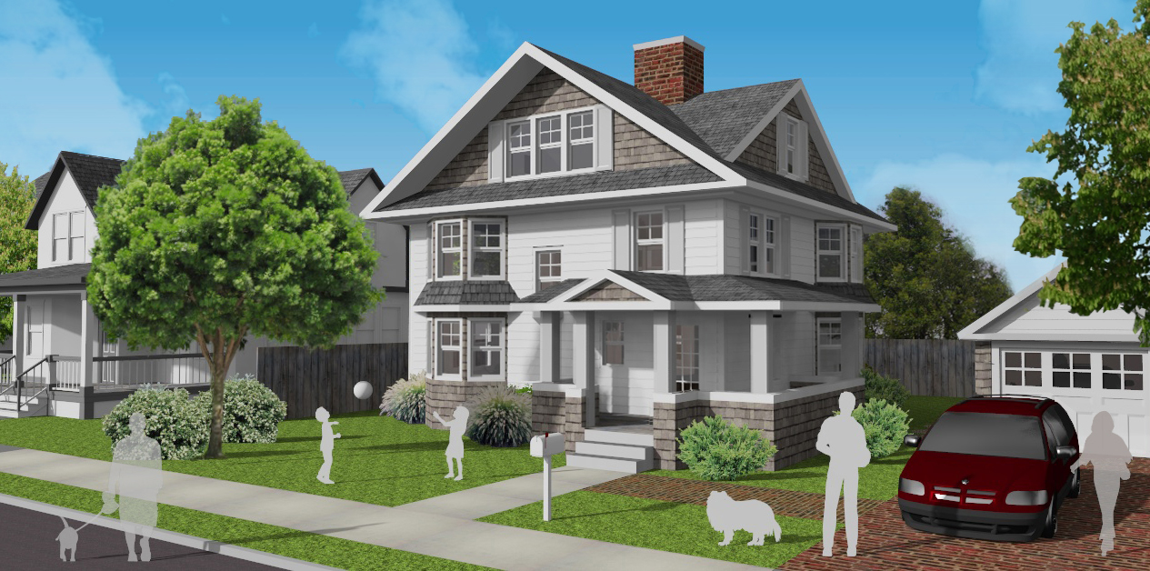


___________________________________________________________________________________________________________________

Name ___________________ Communities #____

_________________________________________________________________________________________________________________________

URBAN (city) SUBURB RURAL
_________________________________________________________________________________________________________________________

